1. According to Stephen Covey in his best-selling book "**The Seven Habits of Highly Effective People**,"

🡪 **Seek first to understand is the most important habit**.   
And we do this by asking questions.  
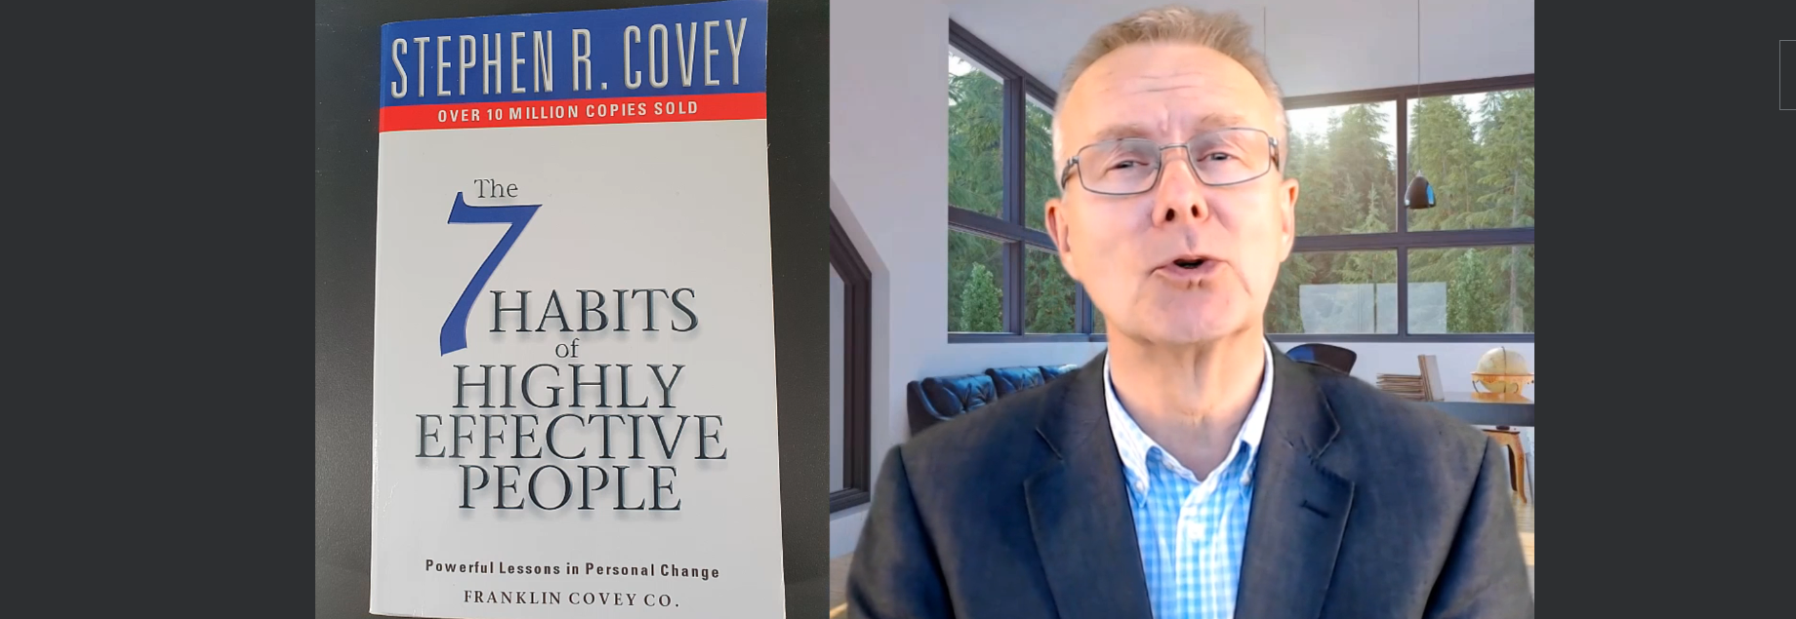

1. 
2. Questioning is a normal part of how we communicate with people.   
   We use them in
   1. our close relationship,
   2. when talking to our friends, family,
   3. At social gatherings and occasions,
   4. In our professional lives when talking to our managers, training, coaching, conference etc.
   5. We even question in our personal thoughts.  
      **Thinking has been described as asking questions and answering them**.
3. Agenda of this course:
   1. The **big fundamental question** that we are going to explore in this course is **How effective are our questions?**
4. 
   1. I will give you **clear and concise roadmap** of  **How best to use questions** so that we can really understand people and situations and therefore build better, stronger relationships helping you reduce tension and conflicts.
5. To help you do that, we will explore   
   
   1. **Different question types**, their uses and impact, how they work, how they add information to a situation.
   2. **Question Funnels:** 
      1. Sequence of questions that we can put together for most impact in different types of situations.
      2. For Example: the sequence of questions we put in sales situation would be very different to the sequence of questions we might use in a personal relationship situation.
   3. **Question Traps**:
      1. What are all the traps that we all fall into when we’re dealing with questions and when we want to understand things.
      2. We become completely complacent (self-satisfied **without being aware of some potential danger) as we take for granted our ability to ask questions and often as a result, our questioning is ineffective**.  
         It is not giving us the information that we think it is.
   4. **Listening Tips:**
      1. Because once we start asking really good questions, it is critical to be able to really listen to the responses we get.  
         😊 Many of us are not good listeners.  
         Those responses will inform further questions and it will help us really get to the root of the situation or a circumstance.
   5. **Practice**:
      1. We will talk about ways we can try out, practice and hone your questing skills to make us a really effective questioner.
6. 
   1. By completing the different elements.
      1. There will be video sessions.
      2. Activities.
      3. Exercises.
      4. Recommendations of things we can do to practice, to try out and experiment in the real world.